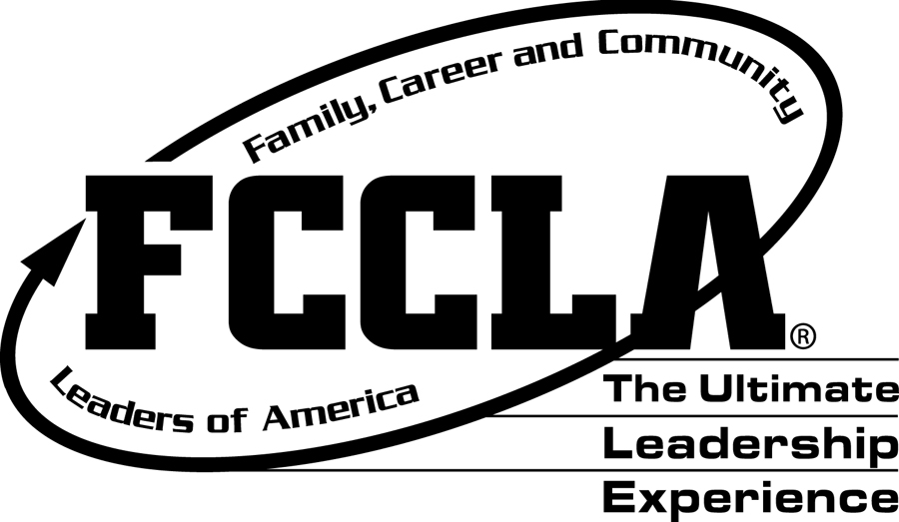
FCCLA Leadership Activities and Events
To improve your leadership skills and the leadership activities of our chapter, we have implemented a Leadership Grade that will be a part of the semester grade. This grade will be based on your attendance at specific leadership activities and your participation in the FCCLA organization.
There will be 100 points required per semester for the Leadership Grade. Students with the highest leadership points for the year will be acknowledged with a High Points award.
Leadership points are DUE December 13th!
The following are ways to earn points.

Event/Activity | Date | Points
Chair Event | Ongoing | 20
Fall Fundraiser | Ongoing | 20+
CTE Celebration (attending or volunteering) | August 12th | 30
August Chapter Meeting | August 15th | 20
Competition Meeting | August 20th | 30
August Kick-off Party** ($5) | August 28th | 30
September Activity – Carnival | September 10th | 30
September Chapter Meeting | September 19th | 20
*Fall Leadership Camp** ($160) | Sept.25th – Sept.27th | 100
October Chapter Meeting *tentative | October 17th | 20
October Activity | TBA | 30
Fall Advisory Meeting | October 30th | 30-50
*FCCLA Fall Leadership Conference** ($70) | November 7th | 40
November Chapter Meeting | November 21st | 20
November Activity | TBA | 30
December Chapter Meeting | December 5th | 20
December Activity – Holiday Party ($5) | December 11th | 30
Volunteer Hours (5 points per hour) | Ongoing | 40
*Serve as an Officer (weekly meetings required) | Ongoing | 30
Student Choice | Ongoing | Varies
Total Points Required |  | 100

*Must have paid FCCLA dues to participate in these activities.
** Indicates there is a fee associated with this event/activity.
More information on the Career and Technical Student Organization, FCCLA (Family, Career, and Community Leaders of America) is available on the state and national websites.
State: http://www.azfccla.org
National: http://www.fcclainc.org/

